[CEN 323 ] Computer Organization & Assembly Language
Lab 6 Journal

Name : Fatima Asad
Enrollment Number: 01-135232-020

Lab Deliverables (submission guideline)

Create a folder named after your enrollment number and add the following files:
  - Create a folder named YourRollNumber_Lab6 containing:
- .asm files of the three practice tasks.
- Add full screen screenshots of the code and output in this word file.
  - Zip the Folder and upload to LMS.

Lab Task

Task 1:
Code (TEXT):
.model small

.data
msg db 10,13, "Letters from Z-A $"

.code
main:
mov ax, @data
mov ds, ax
mov dx, offset msg

mov ah, 09
int 21h

mov cl, 26
mov dl, 90

L1:
mov ah, 02
int 21h
dec dl

loop L1

mov ah, 4ch
int 21h

end main

Screenshot (CODE):
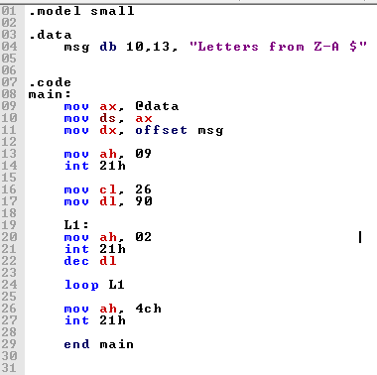

Screenshot (OUTPUT):
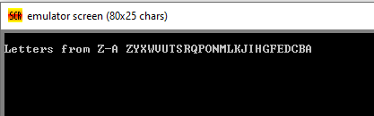

Task 2:
Code (TEXT):
.model small

.data
num dw 9

.code
main:
mov ax, @data
mov ds, ax

mov cx, 9
MyLoop:
mov ax, cx
mov bl, 2
div bl
cmp ah, 0
je escape ; even case

mov dx, cx ; odd case
add dx, 48
mov ah, 2
int 21h

escape:

Loop MyLoop

mov ah, 4ch
int 21h

end main

Screenshot (CODE):
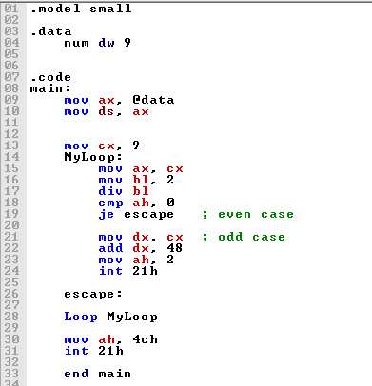

Screenshot (OUTPUT):
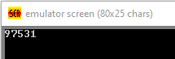

Task 3:
Code (TEXT):
.model small

.data
msg db 10,13,"the highest number is: $"

.code
main:

mov ax,@data
mov ds,ax

mov bl,0
mov cx,10

MyLoop:
mov ah,1
int 21h

cmp al,bl
jg swap
jmp skip

swap:
mov bl,al

skip:
loop MyLoop

mov dx, offset msg
mov ah,09
int 21h

mov dl, bl
mov ah,02
int 21h

mov ah,4ch
int 21h

end main
Screenshot (CODE):
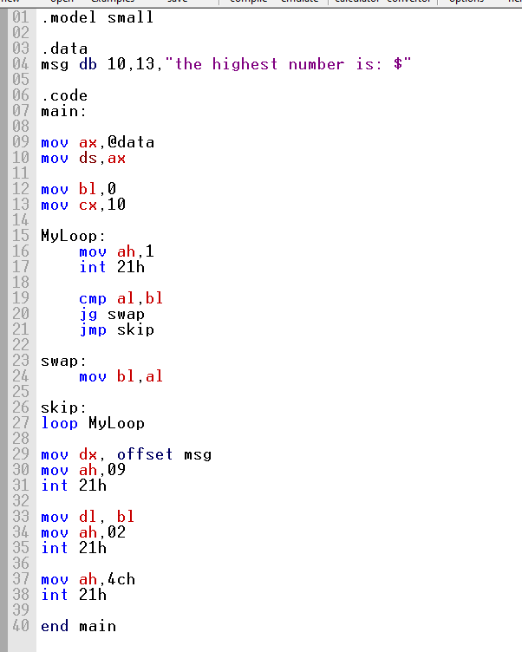

Screenshot (OUTPUT):
